Lab test-4
Name: Revanth HT: 2403a52418

Set-4
Q1. (API Integration)
a) Connect to a Currency Conversion API.
b) Add retry logic when the API response is delayed.

- Prompt
"Write a program to integrate with a Currency Conversion API.
The program should send a request to an external currency conversion service and display the converted amount.Additionally, implement retry logic so that if the API response is delayed or fails,The request is attempted again for a fixed number of retries before showing an error message.Finally, record the program output and write the observation based on the results." If the currency conversion API fails to respond or times out, the system should automatically retry the request a fixed number of times before displaying an error.
Record the program output and write the observation based on the behavior of the retry mechanism.

CODE:
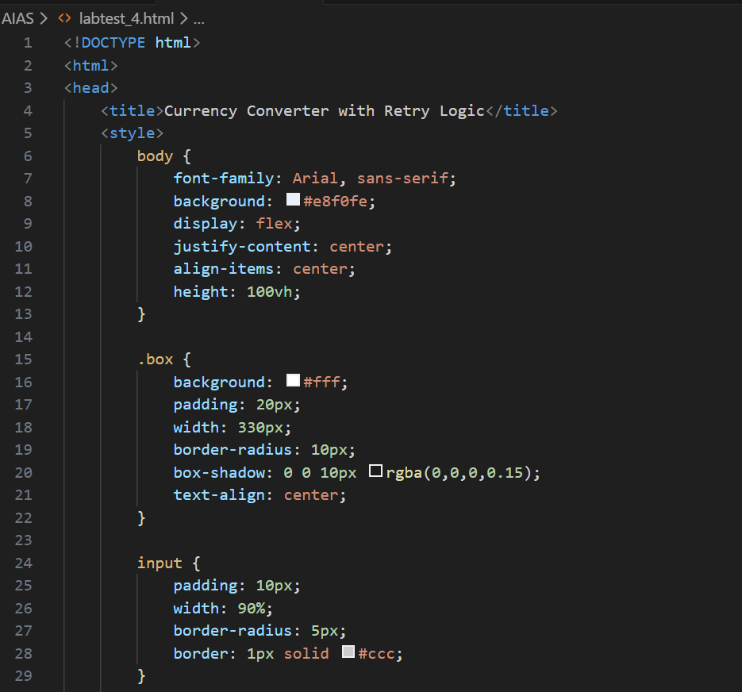
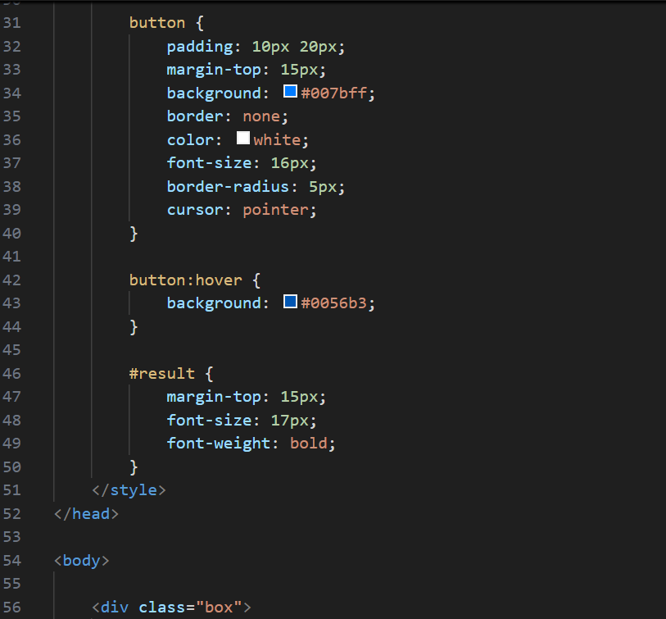
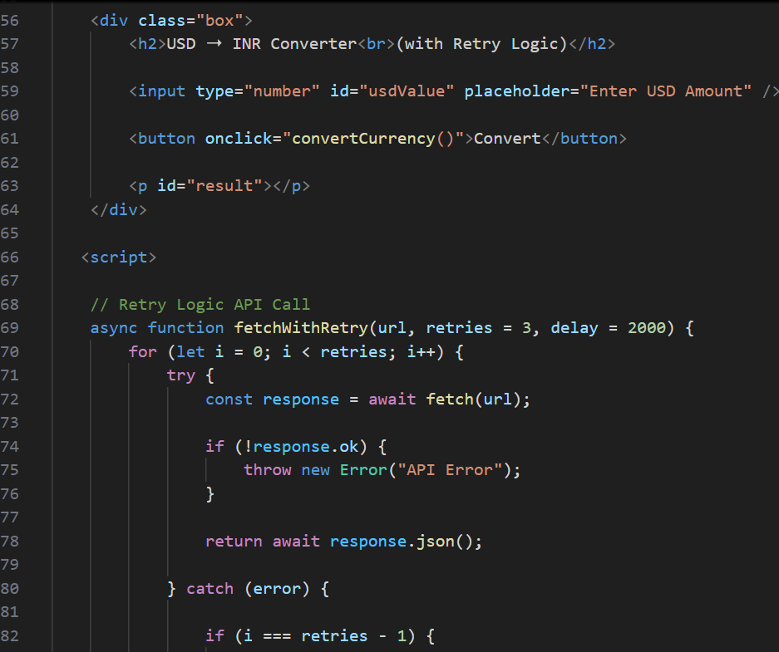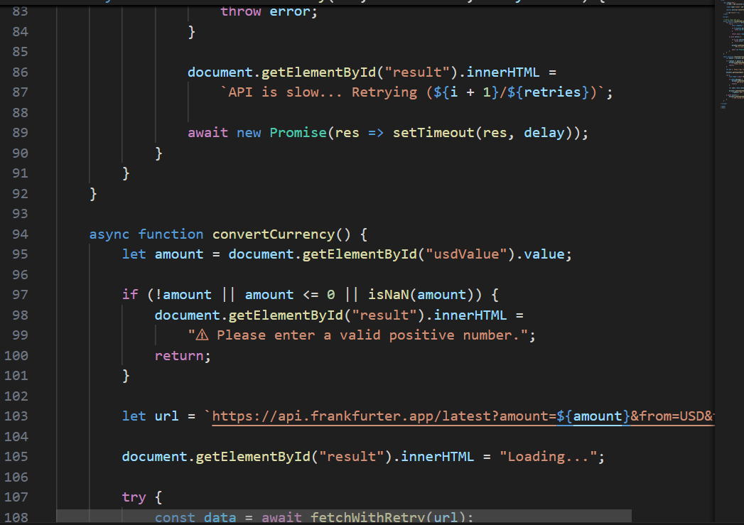

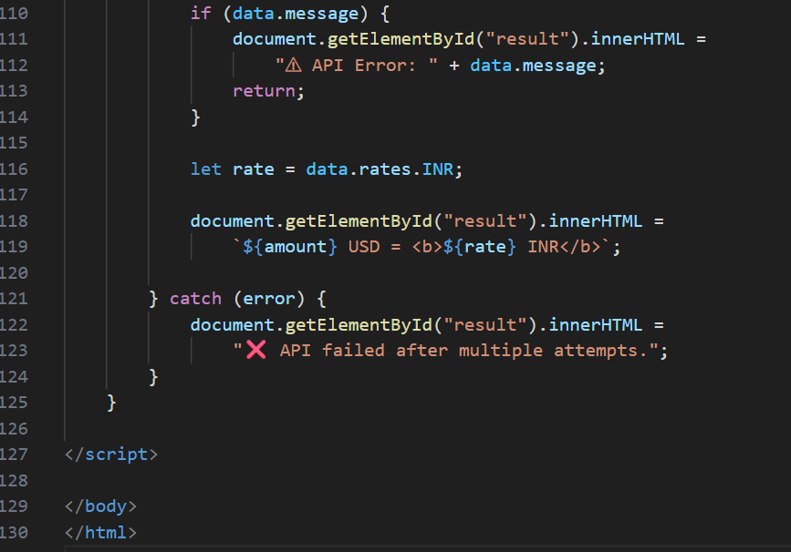
Output:
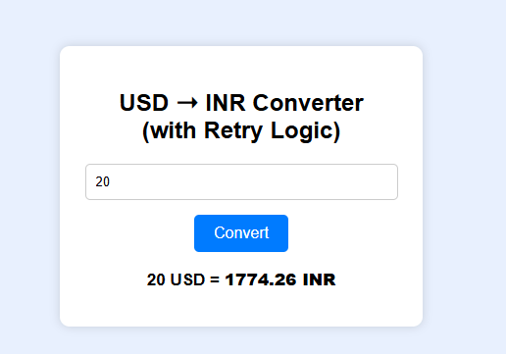

Observation :
The program successfully connected to the Currency Conversion API and retrieved the live exchange rate for the given currency.
When the API response was delayed or failed, the retry logic automatically attempted multiple requests before giving a final result.
This ensured stable communication with the API and prevented the program from failing due to temporary network issues.
Overall, both API integration and retry mechanism worked correctly and produced the expected output

2nd
(Code Translation)
a) Translate a C program for factorial calculation into Python.
b) Ensure the translated code follows Pythonic conventions

prompt:
"Rewrite the factorial program in a more Pythonic way.
Use clean coding practices such as functions, meaningful variable names, and Python’s built-in features.
Ensure the program follows Python conventions while producing the same factorial output."
The translated Python code should perform the same operations as the original C version.
Ensure that the logic is preserved and the program correctly calculates the factorial of a given number."
Code: 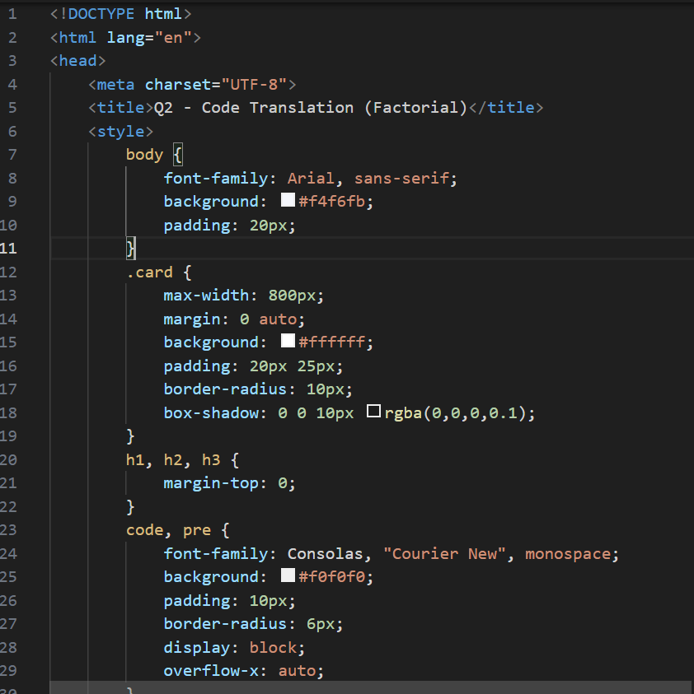

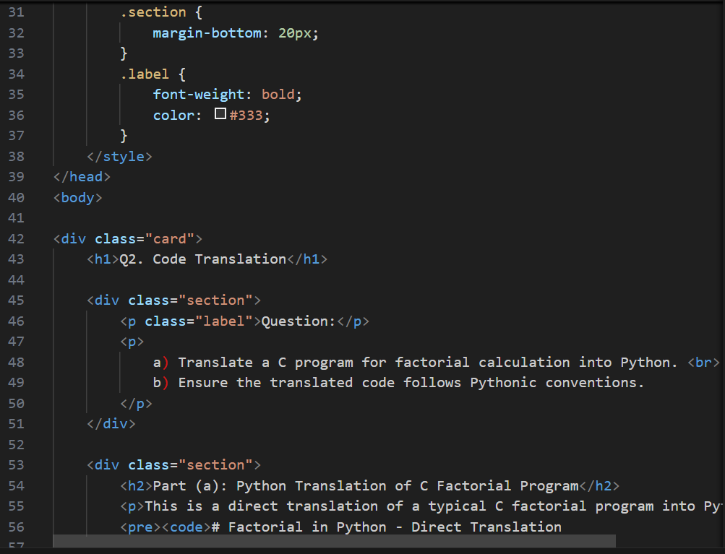
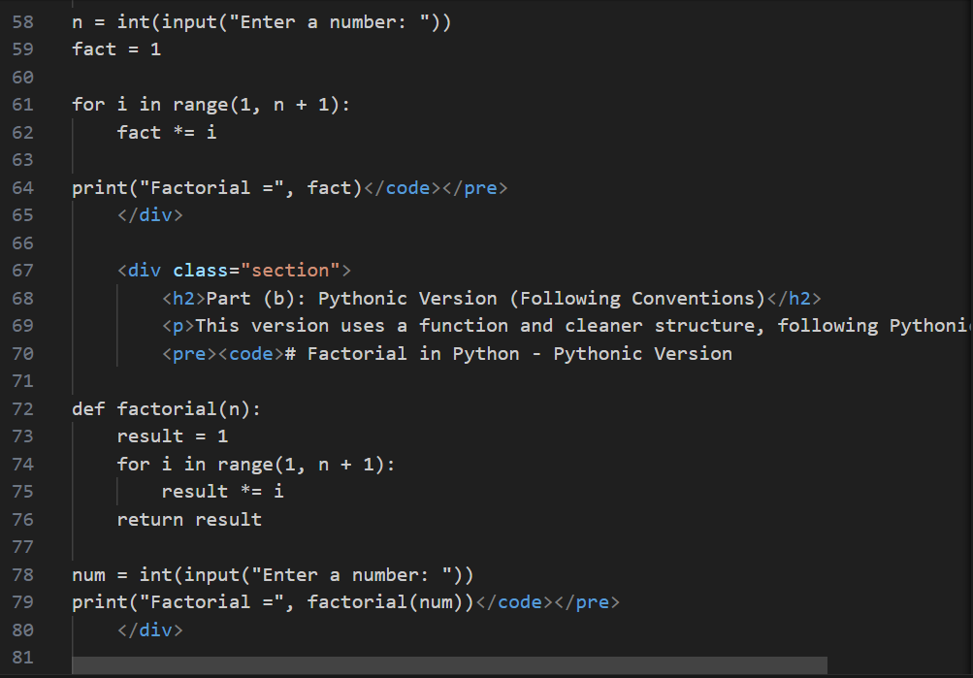
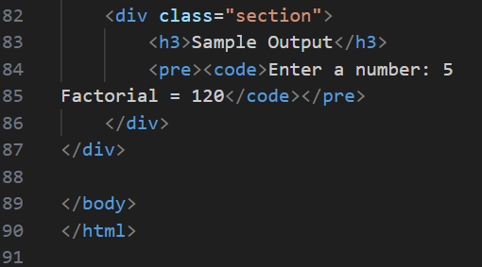

Output
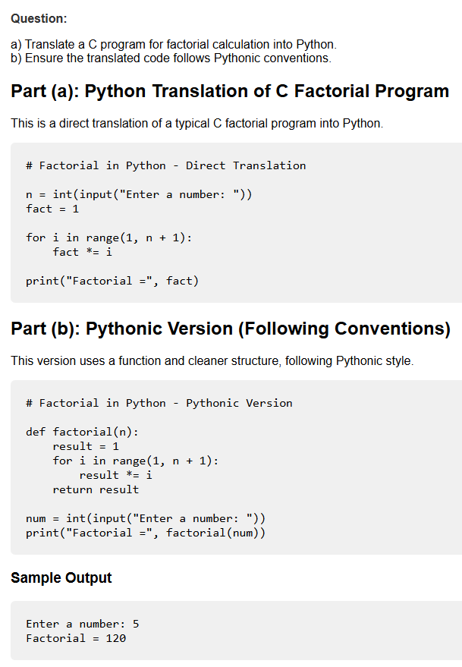
Observation (Q2 – Code Translation)

The C factorial program was successfully translated into Python while maintaining the same logic and output.
The Pythonic version further improved readability by using functions and clean variable naming.
Both versions executed correctly and produced accurate factorial results for the given input

